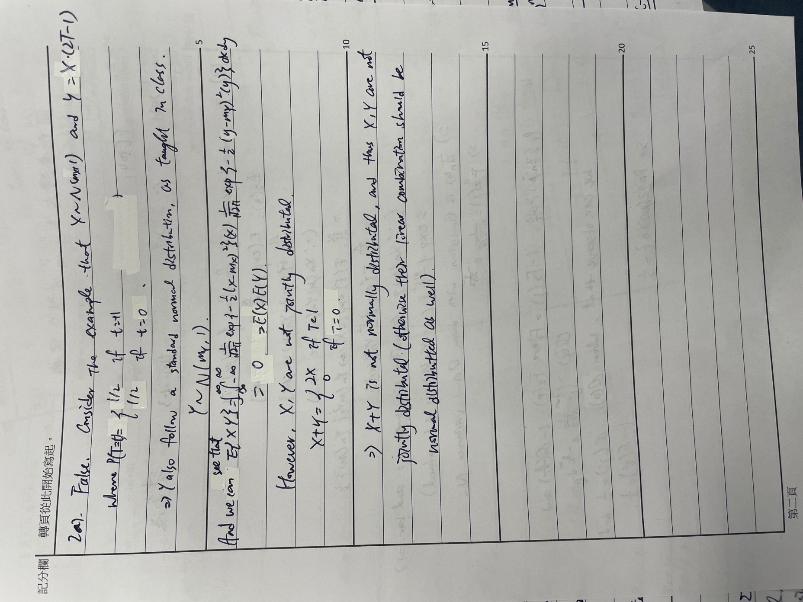

I didn’t do Q4.

